Exercise 1: Introduction To ArcGIS

Jatin Chowdhary

Lab Section #03

Wednesday, September 27th, 2017

Michele Tsang

1. In the Hamilton folder, there are:

* 13 Shapefiles
* 1 Raster Dataset
* 1 Personal Geodatabase (8 Personal Geodatabase Feature Classes Inside)
* 1 Map Document
* 2 Layers
* 1 dBASE Table
* 2 Coverages (1 Point Feature Class & 1 Tic Feature Class In EACH Coverage)

2. The FID for the largest polygon in the ONwer.shp file is 38

3. Wetland: Generic/unknown is associated with this polygon

4. There are 1175 records in this table

5. The name of this coordinate system is GCS_North_American_1983

6. The name of the Datum is D_North_American_1983

7. The unit of measurement is Degree

8. DMTI Spatial Inc. created this data set. It was published in 2006-07-15

9. The Horizontal Datum Name of this data set is: North American Datum of 1983

10. Workspaces are the directories, databases, and folders on a storage device that hold numerous datasets, including geodatabases, as well as external databases in many file formats (i.e. Shapefiles, JPEG, CAD, DXF, dBASE, GML, etc). A workspace consists of a single folder containing many datasets and related documents that are organized around themes or projects. (i.e. In a province-wide GIS, the data might be organized by province, and inside those folders will be relevant data for that province).

11. The purpose of a scratch workspace is to be used by scripts and models as geoprocessing services. It points to a known folder that is read-only and can be used to write file-based data to.

12. A shapefile is an Esri vector data storage format used to store attributes (i.e. location, shape, etc.) of geographic features. The 3 required components to a shapefile are [.shp], [.shx], and [.dbf]. The [.shp] file is the shape format (the feature of the geometry). The [.shx] file is the shape index format. It is a positional index of the feature geometry to allow seeking forwards and backwards quickly. The [.dbf] file is the attribute format and defines the columnar attributes for each shape

13. A layer file stores the path to a source dataset and other layer properties. In layman's terms, a layer file is just a link/reference to the actual data, but it does NOT store the data itself. The data is stored inside shapefiles. The shapefile contains the source data, while the layer file "points" to it.

14. 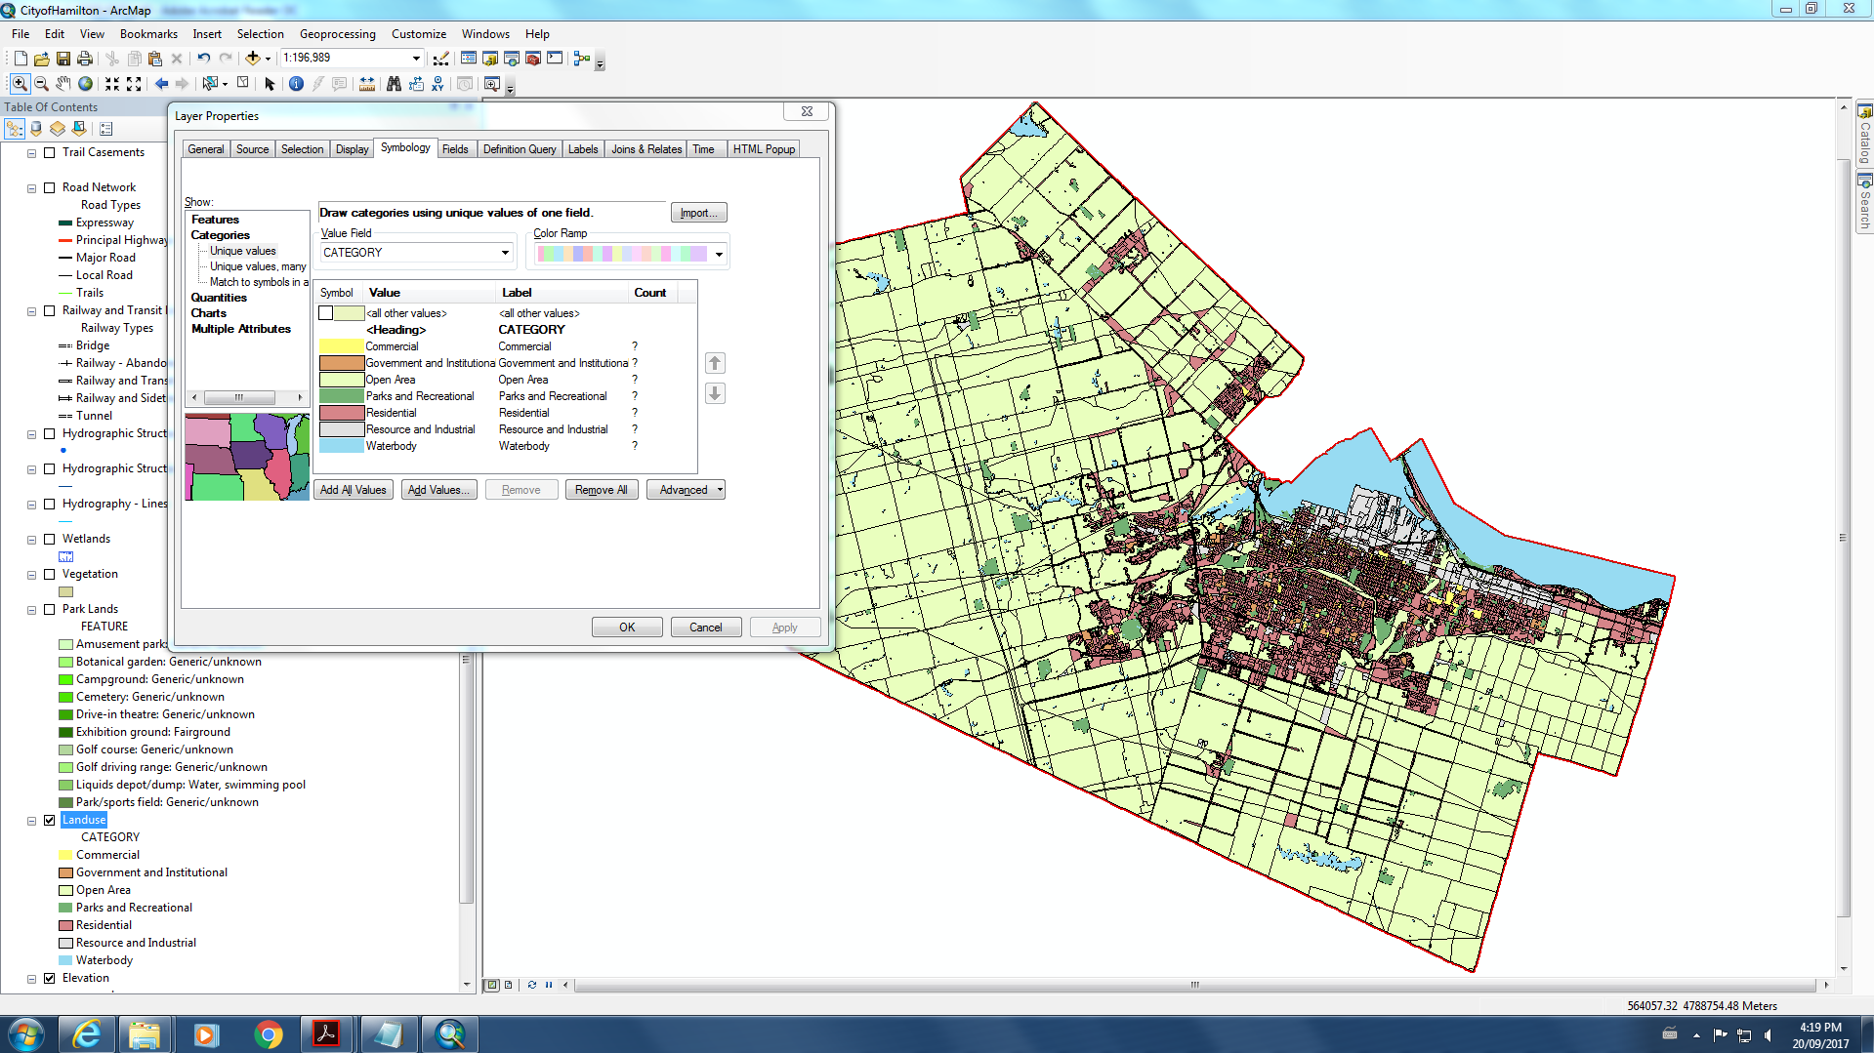

15. The Extent of the Landuse layer file is 43.471057 dd (Top), 43.471057 dd (Bottom), -80.248707 dd (Left), -79.617591 dd (Right).

16. There are 242 educational buildings

17. The elevation layer has 3029 columns, and 2018 rows. The cell size is 0.00020833333, 0.00020833333. The average elevation is 212.1976034517746 meters [above sea level].

18. In the Road Network Layer, there are 18475 Road Types. These include 583 Expressways, 167 Principal Highways, 2898 Major Roads, 13743 Local Roads and 1084 Trails.